

**Project Report**

**CSE 327: Software Engineering**

**Semester: Fall 2019**

**Section: 4**

**Project: Boi-Mela Web Application**

**Submitted by-**

**Talha Yamin-1712731642**

**Sakib Ahmed - 1712442042**

**Table Of Contents:**

1. **Introduction 2**
   1. Purpose 2
   2. Project Scope 2
2. **Overall Descriptions 3**
   1. User Classes, Roles and Characteristics 3
   2. Operating Environment 3
   3. System Design 4
   4. Stakeholders 4
   5. Assumptions and Dependencies 4
3. **System Design 5**
   1. Requirements 5
   2. System Features 5
   3. Future Scopes 6
4. **Project Diagrams 7**
   1. Class Diagram 7
   2. Sequence Diagram 8
5. Registration 8
6. Login 9
7. Search 10
8. Latest Book Release 11
9. Create Stalls 12
   1. Use Case Diagram 13

**Appendix A:** Questionnaires 14

**Appendix B:** User Stories 15

**1.Introduction:**

Every year we have the Ekushey Boi Mela and we all know how hectic it can become. It becomes a huge task just to find and then acquire newly released books. In order to avoid all the chaos and make people’s lives easier, we are introducing the boimela web application. This is a project work undertaken in context of both customers and stall owners. We have tried to design the application in such a way that the user may experience no difficulty in using this and further expansion is possible.

**1.1 Purpose:**

The document is about the software requirements specification (SRS) for the Boi Mela web application. The goal of this document is to provide an elaborate description of the requirements regarding the Boi Mela web application. The following chapters contain all the necessary requirements for the application.The report consists of use cases that outline interactions the users will have with the system. It also consists of the class diagrams, functional and non-functional requirements.

**1.2 Product Scope:**

This product aims to provide services that are in demand during Ekushey boi mela. People need an easy way to navigate through the hectic boi mela and get the books they desire. So the web application will help to achieve this goal.

**2.Overall Description:**

The web application is designed to help book lovers walk through a virtual boi mela. Aimed to guide readers and inform them about the latest book releases, the site provides a navigation to their favorite bookstores and search for books by individual genre. It is designed to help ease the navigation and experience of visiting the book fair as it is crowded and providing a technological solution to this end would be worthwhile.

**2.1 User Classes, Roles and Characteristics**

1. **Physical Actors:**

**i.Owners**: Stall owners of the book fair will create an account that is, they will sign up and have their own profile from where they will upload the name, genre, release date, author name of the books that they published and displayed at the boi mela.

**ii.Visitors**: They will be able to check information on stalls and search for books they want from the website.

1. **System Actors:**

**i.Client:** Client is a system that connects to the server and will fetch data and bring necessary changes.

**ii.Server**: Server will accept connections from clients and save the results.

**iii.Database**: Store data

**iv.Database editor**: Database editor will hold all the necessary database tools and make changes to the names of the books, genre name, book pictures and other necessary changes required.

**2.2 Operating Environment**

The program will operate on most popular operating systems that support internet connection as it is a web application. Will work on Mac OS, Microsoft Windows as well as Linux. The product will operate on popular browsers such as Google Chrome and Mozilla Firefox. The website can also be viewed on browsers on mobile devices. The product will only work when there is a working internet connection to be able to load the website and also send and retrieve data from the website.

**2.3 System Design:**

1. **Front End** - HTML5, CSS3, Bootstrap, jQuery, JavaScript
2. **Database** - SQLite
3. **Backend** - Python and Django Framework

**2.4 Stakeholders:**

Stakeholders include end-users who interact with the system and everyone else in an organization that may be affected by its installation.

**1.**  Customers

**2.** Book Stall Owners

**3.** Bangla Academy Administration

**2.5 Assumptions and Dependencies**

Some dependencies such as Bootstrap and JQuery are connected to the website via URLs. As a consequence the website heavily relies on those sources for the URLs being live for as long as the website lives.

**3.System Study**

**3.1 Requirements:**

1. **Functional Requirements:**
   1. Sign Up page for new owners
   2. Interactive website interface
   3. Login page for existing owners
   4. Profile Page for existing owners
   5. Dashboard for existing owners
   6. Search Option for users
   7. Latest Book release for users
   8. Navigation for users
2. **Non Functional Requirements:**
   1. Password constraints must be placed for security reasons.
   2. Username and password both required to login
   3. Valid email needs to be used
   4. Encrypt user passwords
   5. Each user can only access their profiles and cannot interact with other user profiles.
   6. Search will be done by typing the name or author of the book and matched results will be displayed
   7. The books which have been released recently will be categorized by the order of their release dates.

**3.2 System Features:**

1. **Home Page:** Users would see this page when they enter. They can navigate through the site from this page.They can find information on the site as well as information on authors.
2. **Register:** Users would be able to make their accounts for the website by using their email and entering a password and their information. Passwords have constraints in order to protect user accounts. If they already have accounts they would be taken to the login page.
3. **Login Page:** Users with accounts will be able to login here with their username and password.
4. **Latest Book Releases:** Users will be able to check the books that are in stock here. They will be able to check all book names its authors and the stalls they are available in.
5. **User Profile Page**: Users will be able to check their profiles and change any information as they deem.
6. **Search Page:** Users can search the books they desire by their name or they can even search by author name to find all the books by that author. They can see information on the books such as isbn number, release date.
7. **Navigation**: They can see a map of where the mela is.

**3.3 Future Scope:**

Due to time constraints we were not able to add the following:

1. For now users cannot add books through the website. Users were supposed to be able to add the books for their stalls from the dashboard.
2. Users are not sent confirmation mail when they make an account.
3. Sections for food stalls and reviews.
4. Dynamic Navigation page. The map was to show stalls and its respective information as visitors would hover over the map.

**4. Project Diagrams**

**4.1 Class Diagram:**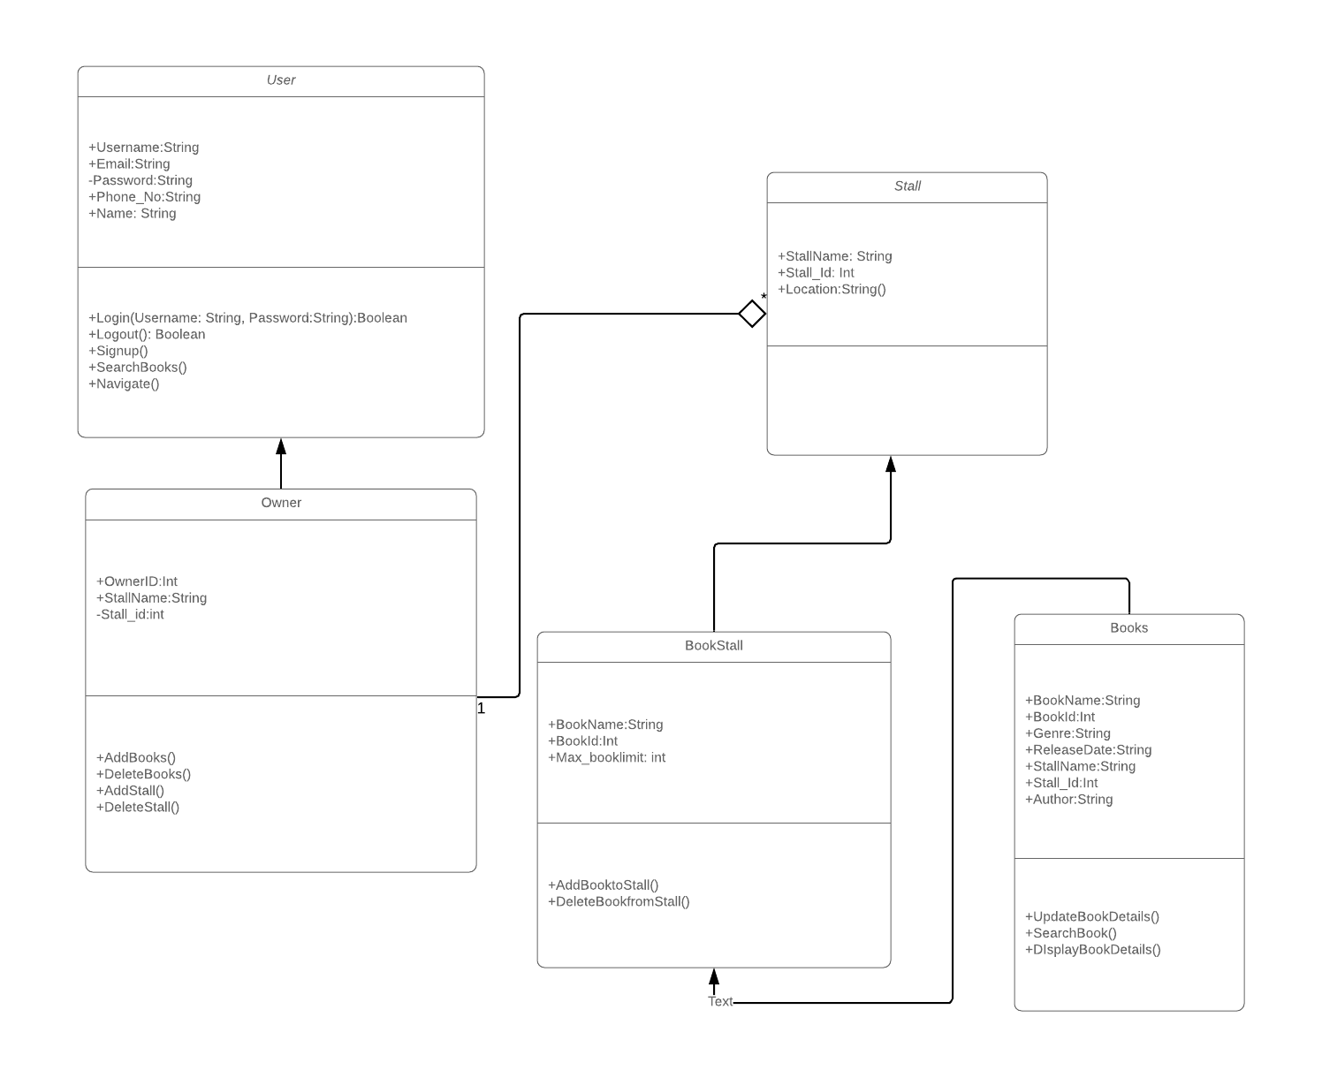

**4.2 Sequence Diagrams:**

**a. Registration:**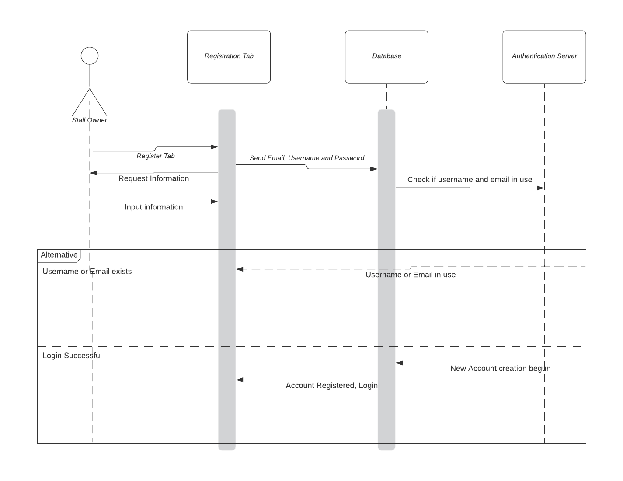

**b. Login:**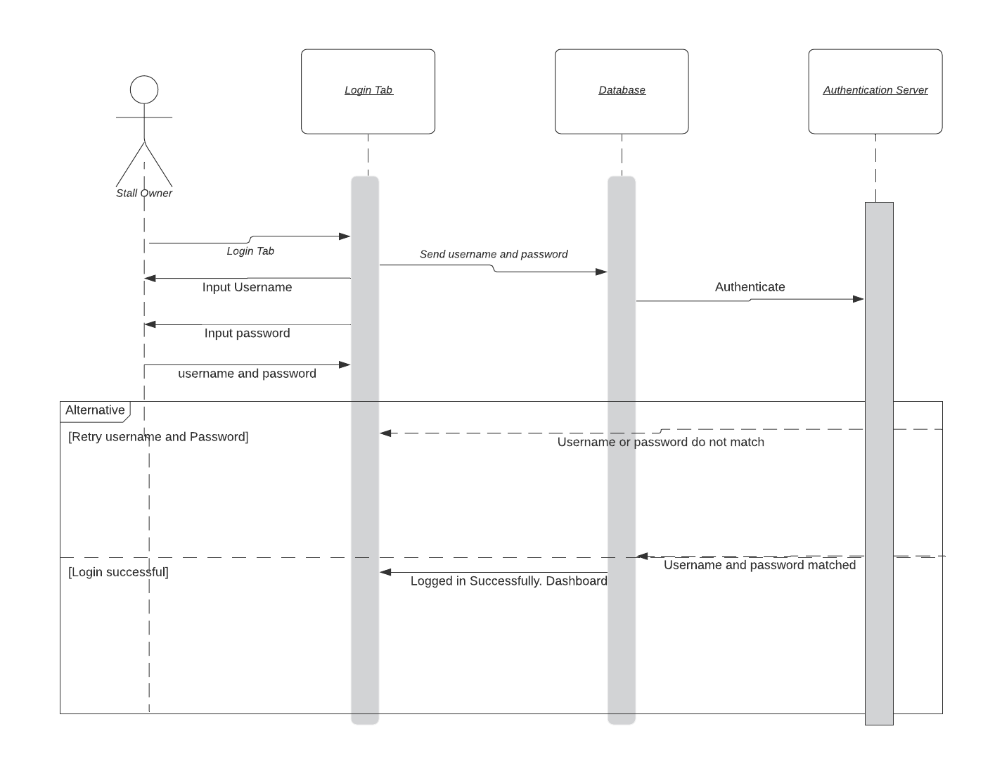

**c. Search:**

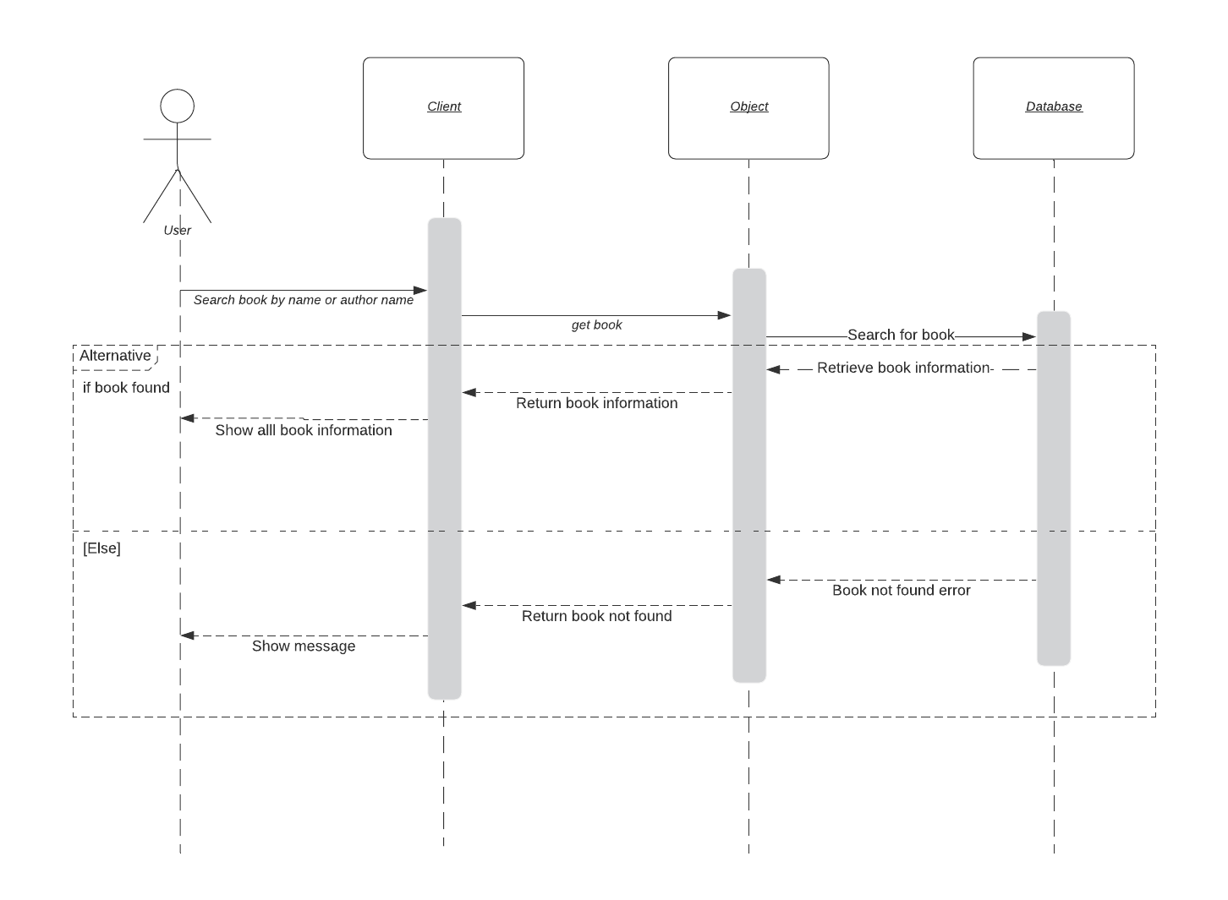

**d. Latest book release:**

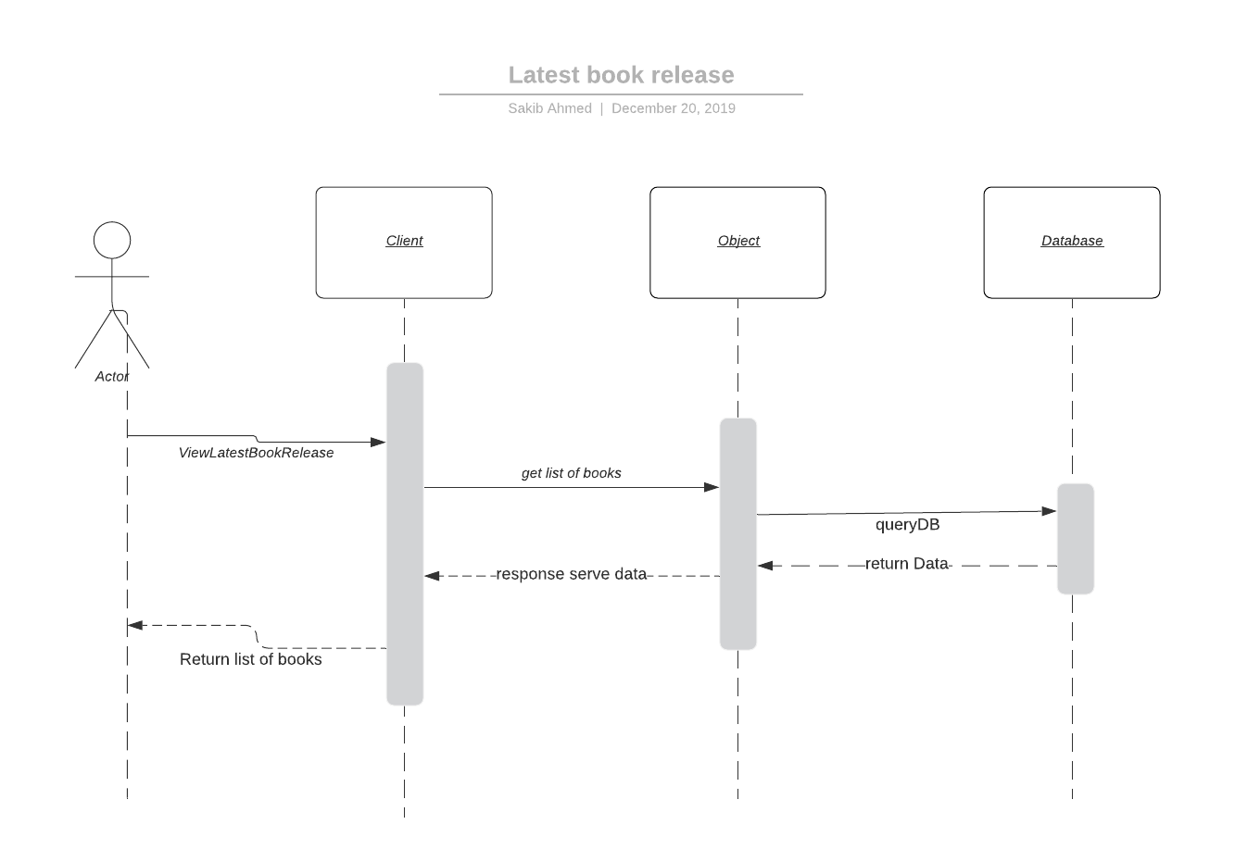

**e. Create Stalls:**

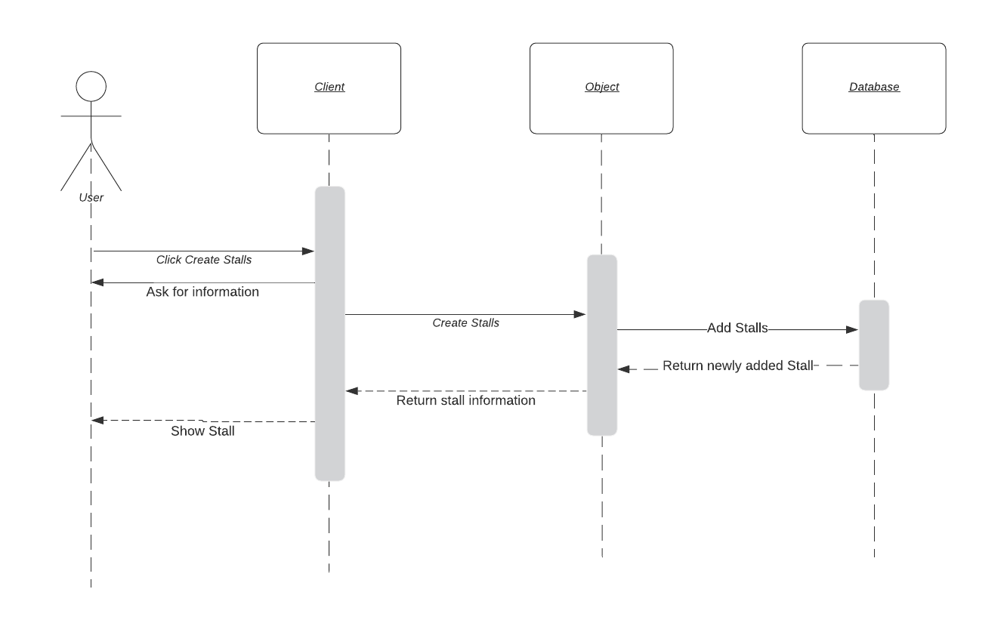

**4.3 Use Case Diagram:**

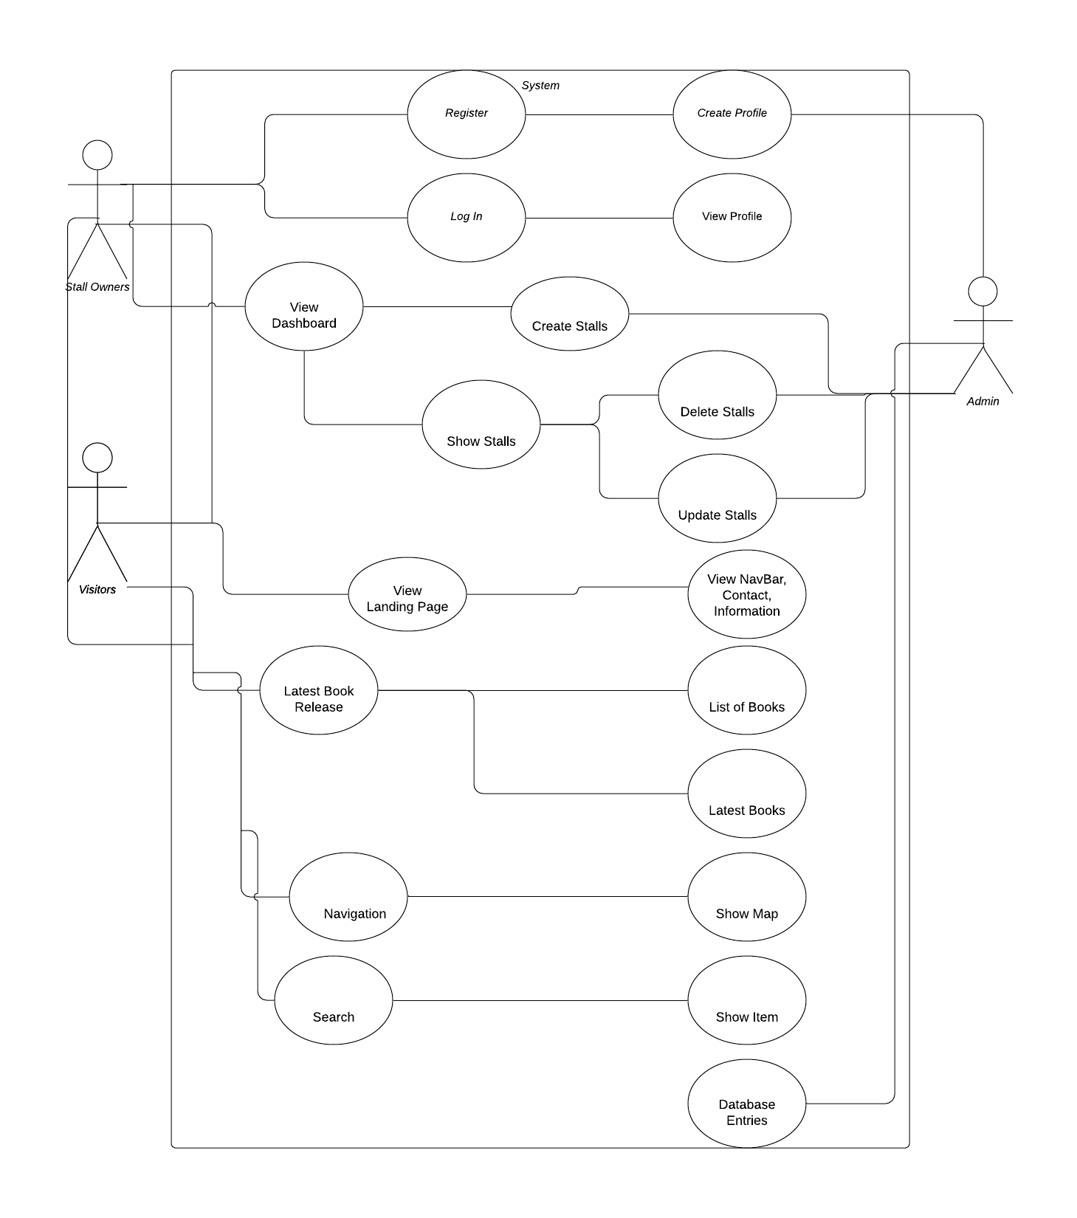

**Appendix A: Questionnaire**

**Questionnaire to Book Stall Owners:**

1. Who are the users?
2. What are the benefits for them?
3. What is the purpose of implementing this website?
4. What functions are required?
5. Would you like to showcase all the books you are selling?
6. Would you like to show the bestselling books?
7. Would you like people to see where your stall is located?
8. Would you like a sign-up feature?

**Questionnaire to Customers:**

1. Would you use this service?
2. What services would you like there to be?
3. Would you want to search books?
4. Would you want to review foods?
5. Would you want to see the latest or popular books first?
6. Would you like to see a map of the fair?
7. Would you like to leave reviews of books?

**Appendix B: User Stories**

**From Customers:**

1. “I Rafsan, as a customer, want an online version of the book fair as it will save a huge amount of time”

2. “I Anis, as a customer, want to be able to go through all the books available in book fair before I even go there”

3. “I Mahin, as a customer, want to be able to check all the new book releases”

4. “I Bulbul, as a customer, want to be able to search the book I want from the book fair”

5. I Shoeb, as a customer, want to be able to search for a book by genres from the book fair”

6. “I Nahin, as a customer, want to be able to see a map of the book fair and see where each stalls are located so I can plan everything beforehand”

7. “I Mohit, as a customer, want to see reviews of all the food stalls available”

8. “I Sahid, as a customer, would want to check reviews on books on what to buy or what’s good”

**From Stall Owners:**

1. “I Mr Shahid, as an owner, want a website to showcase all my products as this will bring in customers”

2. “I Mr Nahid, as an owner, want a more interactive relationship with our customers through the website”

3. “I Mrs Baylen, as an owner, want a website where I can sign up and edit how I want to”

4. “I Mr Farid, as an owner, want the website to be simple so as to bring more customers”

5. “I Mr Putul, as an owner, want a website where it would show the bestselling books and where to buy from”

**From Bangla Academy:**

1. “I Mr Moin want the website as this will bring in more people”

2. “I Mr Gani want the website as it will bring more people to read Bangla books”

**GitHub link:** [**https://github.com/TalhaYamin171/Boimela-Project-CSE327**](https://github.com/TalhaYamin171/Boimela-Project-CSE327)